**DP SM 4.3-2023**

**RULES FOR THE USE OF ACCREDITATION SYMBOL, COMBINED ILAC MRA MARK,  
TEXT REFERENCE TO ACCREDITATION AND**

**REFERENCE TO ILAC MRA SIGNATORY STATUS**

|  |  |
| --- | --- |
| Developed by | DEPARTMENT OF ACCREDITATION ACTIVITIES MANAGEMENT |
| Responsible for revision | INTERNATIONAL COOPERATION AND DEVELOPMENT DEPARTMENT |
| Approved in accordance with | Order No. 106 of 11.07.2023 |
| Effective date | 13.07.2023 |
| Issue | 05 |
| Modification |  |
| Copy | Work copy |
| Substitutes | DP SM 4.3-2020 |

**TABLE OF CONTENTS**

|  |  |
| --- | --- |
| 1 SCOPE………………………………………...……………………………………..……............ | 3 |
| 2 REFERENCES…………………………………………………………….………….………….. | 3 |
| 3 TERMS AND DEFINITIONS……………………..…………………………..…………………. | 4 |
| 4 ACRONYMS AND ABBREVIATIONS…………………………………..…………………..… | 5 |
| 5 RESPONSIBILITY……………………………………………………..……………………........ | 5 |
| 6 POLICY………………………………………………………………………………………...... | 6 |
| 7 BSCA LOGO, ACCREDITATION SYMBOL, COMBINED ILAC MRA MARK…………….. | 6 |
| 7.1 General……………………………………………………………………...……….….. | 6 |
| 7.2 Conditions for use……………………………………………………………..………... | 7 |
| 7.3 Rules for Reproduction ………………………………………………………....…….... | 9 |
| 7.4 Procedure for issuing……………………………………………………………......…... | 11 |
| 8 TEXT REFERENCE TO ACCREDITATION AND/OR STATUS OF SIGNATORY TO ILAC MRA……………..………………………………………………………………………….………. | 11 |
| 8.1 General…………………………………………………..………………………………. | 11 |
| 8.2 References to accreditation………………………………………….……..……….…… | 11 |
| 8.3 Reference to ILAC MRA signatory status of the accreditation body…………………... | 12 |
| 8.4 Reference to ILAC MRA signatory status used by accredited CABs………………….. | 12 |
| 9 APPLICATION RULES FOR SYMBOLS/MARKS AND TEXT REFERENCE BY ACCREDITED CABS…………………………………………………………….…………….….. | 14 |
| 9.1 The rights to the use of symbols/marks and text references………………………..…… | 14 |
| 9.2 Documents and Promotional Materials……………………………………………...….. | 15 |
| 9.3 Documents issued by the results of conformity assessment activities………………….. | 15 |
| 10 APPLICATION RULES FOR SYMBOLS/MARKS AND TEXT REFERENCES BY CONSUMERS OF ACCREDITED CABS…………………………………...………..………....… | 17 |
| 10.1 General……………………………………………………………………………….… | 17 |
| 10.2 Consumers of accredited laboratories………………………………………...………... | 17 |
| 11 UNLAWFUL APPLICATION OF BSCA LOGO, SYMBOLS/MARKS AND REFERENCES TO ACCREDITATION……………………………..….…………………………………………... | 17 |
| 12 APPLICABLE FORMS………………………….……………………………………………… | 18 |
| 13 RECORDS MANAGEMENT…………………..………………………………………...….…. | 19 |
| Annex 1 Image of accreditation symbols for different types of CABs……………………………... | 20 |
| Annex 2 BSCA logo…………………………………………………………...……………….…… | 21 |
| Annex 3 Accreditation Symbol……………………………………………….…………………..… | 22 |
| Annex 4 ILAC MRA mark………………………………………………...……..……………….… | 23 |
| Amendment registration sheet……………………………………...…………………..………….... | 24 |

# 1 SCOPE

1.1 This documented procedure (hereinafter referred to as the procedure) is a document of BSCA management system, developed in accordance with Section 4.3 of RK SM, taking into account the requirements of clause 4.3 of GOST ISO/IEC 17011 and sets the rules for the use of the accreditation symbol, combined ILAC MRA mark of an accredited CAB, text references to accreditation and ILAC MRA signatory status.

1.2 The requirements of this procedure are mandatory for BSCA staff and accredited Conformity Assessment Bodies of the National Accreditation System of the Republic of Belarus (hereinafter referred to as accredited CABs).

# 2 REFERENCES

This procedure refers to the following documents:

Law of the Republic of Belarus No. 437-З of October 24, 2016 *On assessment for compliance with technical requirements and on accreditation of conformity assessment bodies*;

Accreditation Rules, approved by Decree of Gosstandart No.27 of May 31, 2011, as amended by Decree of Gosstandart No. 102 of December 22, 2020;

[STB 911](http://ips/TnpaDetail.php?UrlId=306420) The national flag of the Republic of Belarus. General technical conditions;

STB ISO 9001 (ISO 9001, IDT) Quality management systems. Requirements;

[STB ISO 14001](http://tnpa.by/#!/DocumentCard/373463/501583) (ISO 14001, IDT) (ISO Environmental Management Systems. Requirements with guidance for use;

STB ISO 15189 (ISO 15189, IDT) Medical laboratories. Requirements for quality and competence;

[GOST ISO/IEC 17021-1](http://ips/TnpaDetail.php?UrlId=476790) (ISO/IEC 17021-1, IDT) Conformity assessment — Requirements for bodies providing audit and certification of management systems — Part 1: Requirements;

[STB ISO/IEC 17021-2](http://tnpa.by/#!/DocumentCard/392078/521466) (ISO/IEC 17021-2, IDT) Conformity assessment — Requirements for bodies providing audit and certification of management systems — Part 2: Competence requirements for auditing and certification of environmental management systems;

[STB ISO/IEC TS 17021-3](http://tnpa.by/#!/DocumentCard/351542/476791) (ISO/IEC TS 17021-3, IDT) Conformity assessment — Requirements for bodies providing audit and certification of management systems — Part 3: Competence requirements for auditing and certification of quality management systems;

STB ISO/IEC TS 17021-10 (ISO/IEC TS 17021-10, IDT) Conformity assessment — Requirements for bodies providing audit and certification of management systems — Part 10: Competence requirements for auditing and certification of occupational health and safety management systems;

[STB ISO 22000](http://ips/TnpaDetail.php?UrlId=283163) (ISO 22000, IDT) Food safety management — Requirements for organizations engaged in the food chain;

STB ISO/TS 22003 (ISO/TS 22003, IDT) Food safety management — Requirements for bodies providing audit and certification of food safety management systems;

[STB ISO/IEC 27001](http://tnpa.by/#!/DocumentCard/350978/476001) (ISO/IEC 27001, IDT) Information security management — Information security, cybersecurity and privacy protection Information security management systems Requirements;

[STB ISO/IEC 27006](http://tnpa.by/#!/DocumentCard/392076/521464) (ISO/IEC 27006, IDT) Information security management — Information security, cybersecurity and privacy protection Requirements for bodies providing audit and certification of information security management systems;

STB ISO 45001 (ISO 45001:2018, IDT) Occupational health and safety management systems — Requirements with guidance for use;

[STB ISO 50001](http://tnpa.by/#!/DocumentCard/299849/417790) (ISO 50001, IDT) Energy management systems — Requirements with guidance for use;

[STB ISO 50003](http://tnpa.by/#!/DocumentCard/392077/521465) (ISO 50003, IDT) Energy management systems — Requirements for bodies providing audit and certification of energy management systems;

[GOST ISO 13485](http://ips/TnpaDetail.php?UrlId=519876" \t "_blank) (ISO 13485, IDT) Medical devices — Quality management systems — Requirements for regulatory purposes

GOST ISO/IEC 17011 (ISO/IEC 17011, IDT) Conformity assessment — Requirements for accreditation bodies accrediting conformity assessment bodies;

GOST ISO/IEC 17020 (ISO/IEC 17020, IDT) Conformity assessment — Requirements for the operation of various types of bodies performing inspection;

[GOST ISO/IEC 17024](http://ips/TnpaDetail.php?UrlId=448662) (ISO/IEC 17024, IDT) Conformity assessment — General requirements for bodies operating certification of persons;

GOST ISO/IEC 17025 (ISO/IEC 17025, IDT) General requirements for the competence of testing and calibration laboratories;

GOST ISO/IEC 17043 (ISO/IEC 17043, IDT) Conformity assessment — General requirements for proficiency testing;

[GOST ISO/IEC 17065](http://ips/TnpaDetail.php?UrlId=421186) (ISO/IEC 17065, IDT) Conformity assessment — Requirements for bodies certifying products, processes and services;

RK SМ Quality Manual of the State Enterprise BSCA;

P SM 7.7 Provision on the Technical Commission for Accreditation;

ILAC P8:03 ILAC Mutual Recognition Arrangement (Arrangement): Supplementary Requirements for the Use of Accreditation Symbols and for Claims of Accreditation Status by Accredited Conformity Assessment Bodies

ILAC R7:05 Rules for the Use of the ILAC MRA Mark

Note: When using this Procedure, the latest versions of the referenced documents shall be used. If the reference documents are replaced (modified), then the modified documents should be used. If the reference documents are cancelled without replacement, the provisions of the Procedure, where references are given to them, are applied in the part that does not affect these references.

# 3 TERMS AND DEFINITIONS

In this Procedure the terms are applied in accordance with the Law of the Republic of Belarus *On Assessment of Conformity with Technical Requirements and on Accreditation of Conformity Assessment Bodies*, as well as the following terms with corresponding definitions: :

3.1 **Accreditation body logo:** A symbol used by an accreditation body to identify itself.

3.2 **Accreditation symbol:** A sign indicating that a legal CAB of the Republic of Belarus or a foreign legal CAB has passed all the necessary accreditation procedures of the National Accreditation System of the Republic of Belarus and that they have a valid accreditation certificate.

3.3 **Text reference to accreditation:** A text reference used by an accredited CAB to indicate its accreditation status in the National Accreditation System of the Republic of Belarus.

3.4 **ILAC MRA mark:** A mark registered as a text/symbol owned by ILAC. The ILAC MRA mark is associated with ILAC Mutual Recognition Agreement (ILAC MRA) and may only be used by ILAC and recognized regional cooperation bodies.

3.5 **Combined ILAC MRA mark:** The ILAC MRA mark, used in combination with the logo of the accreditation body – ILAC MRA signatory. The combined ILAC MRA mark can only be used by accreditation bodies – signatories of the ILAC MRA agreement for those activities that fall within the scope of the agreement they have signed.

3.6 **Combined ILAC MRA mark of accredited CAB:** The ILAC MRA mark, used in combination with accreditation symbol issued to an accredited CAB by an accreditation body – ILAC MRA signatory.

3.7 **Text reference to ILAC MRA signatory status** Text reference, used by an accreditation body and/or accredited CABs to indicate that the accreditation body is ILAC MRA signatory.

3.8 **Accreditation scheme:** The rules and processes relating to the accreditation of conformity assessment bodies, to which identical requirements apply.

Note - Accreditation scheme requirements include, but are not limited to, the requirements in STB ISO 15189, GOST ISO/IEC 17020, [GOST ISO/IEC 17021-1](http://ips/TnpaDetail.php?UrlId=476790), [GOST ISO/IEC 17024](http://ips/TnpaDetail.php?UrlId=448662), GOST ISO/IEC 17025, GOST ISO/IEC 17043, [GOST ISO/IEC 17065](http://ips/TnpaDetail.php?UrlId=421186).

# 4 ACRONYMS AND ABBREVIATIONS

The following acronyms and abbreviations are used in this Documented Procedure:

|  |  |
| --- | --- |
| ILAC | International Laboratory Accreditation Cooperation |
| ILAC MRA | ILAC Mutual Recognition  Arrangement |
| IDT | identification of an identical degree of compliance with the international standard (identity in technical content and structure). |
| BSCA, accreditation body | the Republican Unitary Enterprise the Belarusian State Centre for Accreditation; |
| PM | Paper medium |
| IS *Accreditation* | Information system *Accreditation;* |
| EM | Electronic medium |

# 5 RESPONSIBILITY

**5.1** BSCA is responsible for the activities related to the issue of the accreditation symbol and combined ILAC MRA marks used by accredited CABs, the reproduction and the use of combined ILAC MRA marks, as well as text references to ILAC MRA signatory status in accordance with current legislation of the Republic of Belarus in the scope of accreditation, GOST ISO/IEC 17011 (section 4.3) and this Procedure.

**5.2** Accredited CABs are responsible for the activities related to the reproduction and the use of the accreditation symbol, combined ILAC MRA mark, text references to accreditation and to ILAC MRA signatory status, stipulated by current legislation of the Republic of Belarus in the scope of accreditation and this Procedure.

# 6 POLICY

BSCA policy on the use of the accreditation symbol and other references to accreditation establishes the requirements, set forth in this Procedure, referring the following:

* the use and monitoring of the accreditation symbol in combination with any conformity assessment body mark;
* that the accreditation symbol is not applied separately or in a manner that implies that a product, process or service (or any part thereof) is certified or approved by an accreditation body;
* the reproduction of the accreditation symbol;
* any references to accreditation;
* the use of the accreditation symbol and the reference to accreditation status in mass media;
* the use of the accreditation symbol and references to accreditation status by accredited CABs only with respect to specific activities within the scope of accreditation.

# 7 BSCA LOGO, ACCREDITATION SYMBOL, COMBINED ILAC MRA MARK

# 7.1 General

# 7.1.1 BSCA logo

BSCA logo is an official symbol of BSCA to represent its activities. The right to use the logo belongs exclusively to BSCA.

# 

The legal protection of BSCA logo is guaranteed by its registration in the National Centre for Intellectual Property.

# 7.1.2 Combined ILAC MRA mark

The combined ILAC MRA mark indicates that the BSCA is a signatory of ILAC Mutual Recognition Agreement (ILAC MRA) and of an Agreement between BSCA and ILAC to use the ILAC MRA mark (ILAC R7-F1) for the following accredited CABs:

* testing laboratories that meet the requirements of GOST ISO/IEC 17025;
* calibration laboratories that meet the requirements of GOST ISO/IEC 17025;
* medical laboratories that meet the requirements of STB ISO 15189;
* inspection bodies that meet the requirements of GOST ISO/IEC 17020;
* proficiency testing providers that meet the requirements of GOST ISO/IEC 17043.

The combined ILAC MRA mark consists of ILAC MRA mark and BSCA logo.

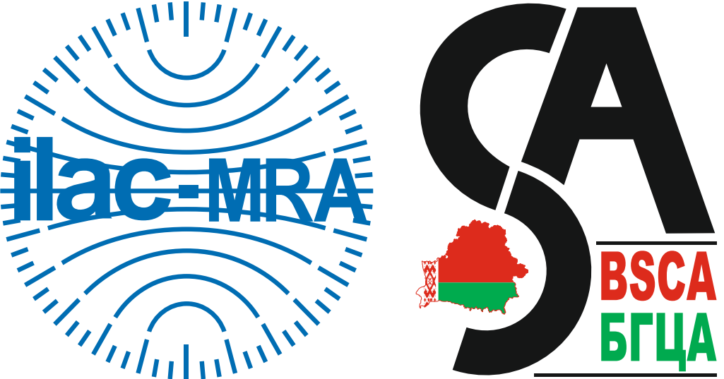

The right to use the combined ILAC MRA mark belongs exclusively to BSCA.

# 7.1.3 Accreditation symbol

The rules and the procedure for the use of the accreditation symbol, the content and linear dimensions are defined by the Accreditation Rules.

The accreditation symbol is issued by the accreditation body to accredited CABs to identify their accreditation status.

The accreditation symbol is a rectangular frame consisting of three fields, comprising:

1. BSCA abbreviation in the Russian and the English languages, respectively: "БГЦА" and "BSCA";
2. the registration number of a CAB accreditation certificate (a unique number) BY/112 Х.YYYY (for laboratories, inspection bodies, proficiency testing providers) and BY/112 ХХХ.YY (for certification bodies);
3. designation of the accreditation schemes and if necessary, designation of the standards, establishing additional criteria for specific types of conformity assessment activities.

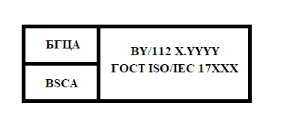

The Examples of BSCA accreditation symbol for different accredited CABs are given in Annex 1.

BSCA accreditation symbol is granted to accredited CABs in accordance with clause 7.4.1 of this Procedure.

# 7.1.4 Combined ILAC MRA mark of accredited CAB

The accredited testing, calibration, medical laboratories, inspection bodies and proficiency testing providers can use the combined ILAC MRA mark of the accredited CAB to demonstrate that their competence is confirmed by an accreditation body – ILAC MRA signatory.

The combined ILAC MRA mark of an accredited CAB is a combination of ILAC MRA mark and the accreditation symbol. Accredited CABs are not allowed to use ILAC MRA mark separately from the accreditation symbol.

|  |
| --- |
|  |

The procedure for issue of the combined ILAC MRA mark of an accredited CAB is set in clause 7.4.2 of this Procedure.

# 7.2 Conditions for use

# 7.1.2 BSCA logo

BSCA logo can be used only by BSCA personnel and in relation to BSCA official activities.

BSCA logo is used:

1. on BSCA official documents;
2. on letterhead paper for BSCA official correspondence;
3. on business cards for BSCA staff;
4. on promotional materials and other BSCA publications;
5. in presentations at trainings and other events organized by BSCA or on behalf of BSCA;
6. at BSCA web-site.

Other use of BSCA logo is allowed only upon written permission of BSCA Director.

The rules for BSCA logo reproduction are set in clause 7.3.2 of this Procedure.

# 7.2.2 Combined ILAC MRA mark

BSCA can use the combined ILAC MRA mark in accordance with the ILAC MRA Mark License Agreement between ILAC and BSCA.

The use of the combined ILAC MRA mark is governed by the rules in the relevant ILAC documents (ILAC-R7, ILAC-P8), in the License Agreement for the use of ILAC MRA mark and shall comply with the scope of ILAC MRA, signed by BSCA.

The permission to use the combined ILAC MRA mark granted by BSCA is not transferable.

BSCA can use the combined ILAC MRA mark only for those accreditation activities, that are within the ILAC MRA Agreement signed by BSCA:

– for testing and calibration laboratories (GOST ISO/IEC 17025);

1. medical laboratories (STB ISO 15189 );
2. inspection bodies (GOST ISO/IEC 17020 );
3. proficiency testing providers (GOST ISO/IEC 17043).

BSCA can use the combined ILAC MRA mark on:

* accreditation certificates;
* letterhead paper for BSCA official correspondence;
* commercial offers;
* promotional materials;
* BSCA website;
* business cards for BSCA staff.

It is prohibited for BSCA to use the combined ILAC MRA mark:

1. so that it could be assumed that ILAC accepts responsibility for accreditation activities carried out by BSCA;
2. when BSCA membership in ILAC expires or is suspended;
3. when ILAC MRA Agreements expires or is suspended;
4. when the agreement between BSCA and ILAC on the use of the combined ILAC MRA mark is cancelled.

# 7.2.3 Accreditation symbol

The accreditation symbol may be used by accredited CABs only within the scope of the accreditation granted.

The accreditation symbol can be used by accredited CABs:

1. on conformity assessment documents within the accreditation granted by BSCA (conformity certificates, certificates of competence, testing reports, calibration certificate, and others);
2. on letterhead paper for BSCA official correspondence;
3. on promotional materials referring the accreditation granted by BSCA;
4. on websites.

Accredited CABs are responsible for proper and correct use of the accreditation symbol within the scope of accreditation granted.

Accredited CABs shall establish principles for the use and protection of accreditation symbols granted in accordance with this Procedure.

Accredited CABs shall control the use of accreditation symbols, take appropriate control measures and prevent any misuse or misleading use of accreditation symbols by accredited CABs or their customers.

# 7.2.4 Combined ILAC MRA mark of accredited CAB

Combined ILAC MRA mark of accredited CAB can be applied only on the basis of the right granted by the accreditation body within the current scope of accreditation, which is included in the scope of the signed ILAC MRA Agreement. The combined ILAC MRA mark of an accredited CAB shall be used in such a way as to prevent the damage of BSCA and/or ILAC reputation.

The combined ILAC MRA of the accredited CAB granted by the accreditation body is non-transferable.

It is prohibited to use the combined MRA ILAC mark of an accredited CAB after the certificate of accreditation is withdrawn, expired or suspended, when the ILAC MRA Agreement signed by BSCA or membership in ILAC are withdrawn, expired or suspended.

The accredited CABs that have received the right to use the combined ILAC MRA mark, have to:

1. terminate the application of the combined ILAC MRA mark of an accredited CAB that could cause damage to BSCA and/or ILAC;
2. notify BSCA without delay on cases of unlawful use of combined ILAC MRA mark of an accredited CAB.

If one accredited CAB has several combined marks of an accredited CAB, their joint use is allowed only in the media (in advertising materials and publications related to the scope of accreditation provided by BSCA, on websites, in presentations, at trainings and other events, etc. ). At the same time, it is not allowed to use several combined marks of an accredited CAB on documents issued based on the results of conformity assessment activities within the scope of accreditation provided by BSCA (test reports, calibration certificates, etc.).

# 7.3 Rules for Reproduction

# 7.3.1 General

The shape, size, colour design of BSCA logo, accreditation symbol, combined ILAC MRA mark of accredited CAB are given in Annexes 2-4 to this Procedure.

Proportions when reproducing the symbol and the marks (ratio of their sides and separate parts) is to be maintained. It is prohibited in any way to distort the logo, the symbol and marks, or to use them in violation of the requirements of this Procedure.

All images of BSCA logo, accreditation symbol, combined ILAC MRA mark, combined ILAC MRA of an accredited CAB presented in this Procedure are for informational purposes only and are not used as a template for copying and scanning. The templates of the accreditation symbol and combined ILAC MRA mark of an accredited CAB for reproduction are stored at BSCA and issued to accredited CABs upon request in accordance with the rules set forth in clause 7.4 of this Procedure.

Accreditation symbol and combined ILAC MRA mark of an accredited CAB can be used only together with the logo of the accredited CAB and are placed on one page of the document. If an accredited CAB does not have a logo, the accreditation symbol and the combined ILAC MRA mark must appear together with the name of the accredited CAB on the same displayed page of the document.

# 7.3.2 BSCA logo

BSCA logo can be presented in black and white or in colour in accordance with Annex 2:

1. black (RGB: 0-0-0) – white (RGB: 255-255-255) or
2. in RGB system in the following colours: red (RGB: 255-0-0) – green 34-139-34) – white (RGB: 255-255-255) – black (RGB: 0-0-0).

The logo shall be represented in the form and proportions according to Annex 2.

It is possible to stretch or compress the picture in order to increase or decrease it while maintaining the proportions (the ratio).

The logo image is a set of two stylized letters in Russian and English (СА and SA), which are abbreviations of the phrases «Система аккредитации» and «System of Accreditation» in Russian and English, respectively.

In the lower right corner of the logo there is the abbreviation of the organization, which is the accreditation body, in Russian and in English respectively: “Белорусский государственный центр аккредитации” (БГЦА) and “Belarusian State Centre for Accreditation” (BSCA). In the bend of the lower part of the letter S the contours of the territory of the Republic of Belarus are depicted using the elements and colours of the national flag of the Republic of Belarus according to STB 911 (for colour representation).

BSCA logo shall be depicted using the technology that ensures its clear depiction, including the technology of embossing, relief, stamping, printing or in electronic form.

# 7.3.3 Accreditation symbol

The accreditation symbol shall have a clear identification of the granted accreditation: of a particular accredited CAB and a particular scope of its activity.

The dimensions of the accreditation symbol are chosen by an accredited CAB that has received the right to use it by scaling the dimensions while maintaining proportions. The basic dimensions shall not be less than those indicated in Figure 3.1 of Annex 3.

When depicting the accreditation symbol the following conditions shall be met:

* the appearance (shape and proportions) of the accreditation symbol should not be distorted;
* all letters and numerals should be discerning, clear and legible and located in the middle of the fields of the accreditation symbol;
* the background on which the accreditation symbol is depicted shall be contrasting and shall not impede the legibility of accreditation symbol.

For alphabetic and numerical designations of the accreditation symbol fonts are used:

1. “BSCA” и “БГЦА” - Cambria 5 pt;
2. for the registration number of the certificate of accreditation and the designation of the accreditation scheme - Cambria 5 pt.

The abbreviations “BSCA” и “БГЦА”, the registration number of the certificate of accreditation and the designation of an accreditation scheme are performed in black on white or light background (if necessary and if agreed with the accreditation body, other conditions for marking can be applied).

All alphabetic and numeral designations of the accreditation symbol are placed in the frame, taking into account the minimum indentation from the external borders of the symbol in accordance with Figure 3.2 of Annex 3.

There shall be no irrelevant texts or graphic images in the area of protective field of the accreditation symbol according to Figure 3.3 of Annex 3.

The accreditation scheme is designated without the year of approval.

The accreditation symbol shall be depicted using the technology that ensures its clear depiction, including the technology of embossing, relief, stamping, printing or in electronic form.

The accreditation symbol and the logo of an accredited CAB shall be approximately the same height.

# 7.3.4 ILAC MRA mark

Colour and black-and-white variants of ILAC MRA mark are defined in the document ILAC-R7.

The ILAC MRA mark in the combined mark or in the combined mark of an accredited CAB:

1. shall be reproduced in black and white or in colour PROCESS (CMYK) C100 M56 Y0 K0, or in colour Pantone 293C (blue) or in colour WEBSITE (RGB) R0 G0 B229;
2. shall be used in the original design and proportions;
3. shall not be twisted, compressed or stretched in any way;
4. shall not be portrayed in size that makes the text unreadable;
5. shall maintain similar proportions together with BSCA logo or accreditation symbol. The BSCA logo height in the combined ILAC MRA mark or of the accreditation symbol in the combined ILAC MRA mark of an accredited CAB shall not differ from the height of ILAC MRA mark more than 5%;
6. shall not have “similar” outline with the letters within the ILAC MRA mark, as the outline of the mark is of an individual graphic design; ILAC MRA mark shall always be used in its full version taking into account the requirements of ILAC-R7;
7. shall be applied on the background that does not complicate the readability of the mark;
8. shall be based on the original graphic design (granted to the accreditation body) without the use of photocopies from other ILAC and/or BSCA documents.

The ways to depict ILAC MRA mark in the combined ILAC MRA mark and the combined ILAC MRA mark of an accredited CAB are provided in Annex 4 respectively.

**7.4 Procedure for issuing**

# 7.4.1 Accreditation symbol

When making a positive decision on accreditation, accredited CABs are granted the right to use the accreditation symbol in accordance with Annex 1.

The accreditation symbol is granted by the accreditation body when issuing the certificate of accreditation to an accredited CAB through the automatic generation of the notification on the profile of the accredited CAB in the IS “Accreditation” on the possibility to apply for the accreditation symbol using the form F 4.3-01 after the information is recorded about the decision on accreditation made by the Technical Commission for Accreditation in accordance with P SM 7.7.

# 7.4.2 Combined ILAC MRA mark of accredited CAB

Issue of the combined ILAC MRA mark of an accredited CAB is performed by the accreditation body following the application of an accredited CAB using form F 4.3-02 from BSCA website (www.bsca.by).

Together with the application the accredited CAB shall send to BSCA two completed and signed copies of the Agreement on the use of the combined ILAC MRA mark using form F 4.3-03 from BSCA website ([www.bsca.by](http://www.bsca.by)).

The provision of the combined ILAC MRA mark of an accredited CAB is performed by BSCA through the automatic generation on the profile of the accredited CAB in the IS “Accreditation” of a notification about the the possibility to use the combined ILAC MRA mark as in form F 4.3-04. The notification is generated after the accreditation body has signed an Agreement on the use of the combined ILAC MRA mark of the accredited CAB and entered information about the date of its signing into the IS “Accreditation”. At the same time BSCA shall send by post the copy of the signed agreement on the application of combined ILAC MRA mark of the accredited CAB.

# 8 TEXT REFERENCE TO ACCREDITATION AND/OR STATUS OF SIGNATORY TO ILAC MRA

# 8.1 General

The conditions for the use of text references to accreditation and/or status of signatory to ILAC MRA are similar to the conditions and principles for the use of accreditation symbols in accordance with clauses 7.2.2-7.2.4.

An accredited CAB shall not make statements regarding its accreditation status and/or its accreditation by accreditation body which is signatory to ILAC MRA, that can be treated as misleading or unauthorized, in particular statements that can be misleading regarding the subject of accreditation regarding who is a signatory of ILAC MRA, or the scope ILAC MRA.

It is allowed to use text references to accreditation and/or status of signatory to ILAC MRA in the Belarusian or English languages as agreed with the BSCA.

# 8.2 References to accreditation

# Text references to accreditation can be used as an alternative to the use of the accreditation symbol by accredited CABs.

Text reference to accreditation shall contain:

1. the name of the accredited CAB (according to the certificate of accreditation) and the name of the organization (full or abbreviated), of which the accredited CAB is a part (according to the certificate of registration in the unified state register of legal entities and individual entrepreneurs);
2. the name of the organization which is the accreditation body (full or abbreviated);
3. the name of accreditation schemes (s), the compliance of which (s) is assessed to be met by the accredited CAB;
4. the registration number of the accreditation certificate;
5. the expiry date of the accreditation certificate (if necessary).

*Example*

*[The name of the accredited CAB and the name of the organization (full or abbreviated), of which the accredited CAB is a part] is accredited by the State Enterprise "BSCA" for compliance with the requirements of [– the name of accreditation schemes according to clause 3.8 of this Procedure]. Certificate of accreditation No. BY/112 \_\_\_\_\_\_\_\_\_\_\_.*

# 8.3 Reference to ILAC MRA signatory status of the accreditation body

In order to promote the ILAС MRA Agreement in accordance with ILAC-P5 document the accreditation body shall indicate the information on signing the ILAС MRA Agreement on the issued certificates of accreditation together with BSCA logo for the activities that are within the scope of ILAС MRA (testing, calibration, medicine, inspection, proficiency testing providers):

*“The State Enterprise BSCA is an ILAС MRA signatory in the indicated scope”* – for certificates of accreditation granted to accredited testing, calibration and medical laboratories, inspection bodies, proficiency testing providers.

As an alternative to the use of the combined ILAC MRA mark BSCA can use text reference to the ILAC MRA Agreement for those activities that are within the scope of ILAC MRA (testing, calibration, medicine, inspection, proficiency testing providers):

*Example*

*“The State Enterprise BSCA is a signatory to the ILAC MRA Agreement in the indicated scope" – for certificates of accreditation granted to accredited testing, calibration and medical laboratories, inspection bodies, proficiency testing providers.*

BSCA shall refer to its ILAC MRA signatory status in such a way as not to mislead the interested parties referring who is a signatory, and the scope of the Agreement.

# 8.4 Reference to ILAC MRA signatory status used by accredited CABs

Accredited CABs, together with accreditation symbol or text reference to accreditation can apply a text reference on ILAC MRA signatory status to demonstrate that their activities (testing, calibration, medicine, inspection, proficiency testing providers) are covered by the scope of ILAC MRA).

Alternatively, text references to ILAC MRA (for testing, calibration and medical laboratories, inspection bodies, proficiency testing providers) signatory status can be used instead of combined ILAC MRA mark of the accredited CAB.

Text references to ILAC MRA signatory status can be used only by accredited CABs whose scope of accreditation is covered by the scope of ILAC MRA signed by BSCA.

Text reference to ILAC MRA signatory status shall include the information about the scope of accreditation that is covered by ILAC MRA signed by BSCA.

The combination of text references to accreditation and ILAC MRA signatory status shall contain the wordings shown in Table 1 and also include the current accreditation certificate number.

**Table 1 – Examples of text references**

|  |  |
| --- | --- |
| **Accredited CAB** | **Text reference** |
| For testing laboratories | [The name of the accredited CAB and the name of the organization (full or abbreviated), of which the accredited CAB is a part] is accredited by the State Enterprise BSCA – signatory of ILAC MRA in the scope of accreditation of testing laboratories for compliance with the requirements of [designation of accreditation scheme according to clause 3.8 of this Procedure]. Certificate of accreditation No. BY/112 \_\_\_\_\_\_\_\_\_\_\_. |
| For calibration laboratories | [The name of the accredited CAB and the name of the organization (full or abbreviated), of which the accredited CAB is a part] is accredited by the State Enterprise BSCA – signatory of ILAC MRA in the scope of accreditation of calibration laboratories for compliance with the requirements of [designation of accreditation scheme according to clause 3.8 of this Procedure]. Certificate of accreditation No. BY/112 \_\_\_\_\_\_\_\_\_\_\_. |
| For medical laboratories | [The name of the accredited CAB and the name of the organization (full or abbreviated), of which the accredited CAB is a part] is accredited by the State Enterprise BSCA – signatory of ILAC MRA in the scope of accreditation of medical laboratories for compliance with the requirements of [designation of accreditation scheme according to clause 3.8 of this Procedure]. Certificate of accreditation No. BY/112 \_\_\_\_\_\_\_\_\_\_\_. |
| For inspection bodies | [The name of the accredited CAB and the name of the organization (full or abbreviated), of which the accredited CAB is a part] is accredited by the State Enterprise BSCA – signatory of ILAC MRA in the scope of accreditation of inspection bodies for compliance with the requirements of [designation of accreditation scheme according to clause 3.8 of this Procedure]. Certificate of accreditation No. BY/112 \_\_\_\_\_\_\_\_\_\_\_. |
| For proficiency testing providers | [The name of the accredited CAB and the name of the organization (full or abbreviated), of which the accredited CAB is a part] is accredited by the State Enterprise BSCA – signatory of ILAC MRA in the scope of accreditation of proficiency testing providers for compliance with the requirements of [designation of accreditation scheme according to clause 3.8 of this Procedure]. Certificate of accreditation No. BY/112 \_\_\_\_\_\_\_\_\_\_\_. |

# 9 APPLICATION RULES FOR SYMBOLS/MARKS AND TEXT REFERENCE BY ACCREDITED CABS

# 9.1 The rights to the use of symbols/marks and text references

# 9.1.1 General

An accredited CAB may apply the accreditation symbol, combined ILAC MRA mark of an accredited CAB, text references to accreditation and text references to ILAC MRA signatory status, if:

1. it is accredited and has a valid certificate of accreditation;
2. accreditation has not been cancelled, suspended and the period of validity of the certificate of accreditation has not yet expired;
3. it complies with the requirements of this Procedure;
4. it complies with the requirements in the agreement for the application of the combined ILAC MRA mark of accredited CAB concluded with the BSCA.

Documents issued by accredited CABs on the results of its operations without applying accreditation symbol or the use of text reference to accreditation, do not qualify for a presumption of compliance with accreditation schemes.

Documents issued by accredited CABs on the results of its operations without applying ILAC MRA combined mark of the accredited CAB, or the use of text references to ILAC MRA signatory status cannot qualify for a presumption of conformity with the provisions of the ILAC MRA Agreement.

The accreditation symbol can be applied by an accredited CAB only in the issued scope of accreditation and shall refer exclusively to the object of conformity assessment specified in the protocols (reports, certificates).

The accredited CAB is responsible for the use of accreditation symbol or reference to accreditation of its customers and must ensure their proper application (see. Section 8).

The accredited CAB must inform its consumers concerned, without undue delay, on suspension, reduction of the scope of accreditation or withdrawing accreditation and related impacts.

Consumers of accredited CABs are prohibited to use a combined ILAC MRA mark or text references to ILAC MRA signatory status.

The accredited CAB is obliged to provide BSCA with the information on application of combined ILAC MRA mark of the accredited CAB and the text reference to ILAC MRA signatory status once a month (no later than the 5th working day of the month following the reporting month) through filling the form in the tab “combined mark/text reference'''’ on the profile of accredited CAB at IS “Accreditation”.

# 9.1.2 Suspension of accreditation certificate

In case of suspension of the certificate of accreditation, including suspension of the part of the scope of accreditation, the accredited CAB shall promptly (from the date of suspension of the certificate of accreditation) suspend the issuance of all documents that:

1. contain accreditation symbol (test reports, certificates of calibration, certificates of conformity, calibration labels, etc.);
2. contain combined accreditation ILAC MRA mark of an accredited CAB;
3. contain any reference to accreditation or ILAC MRA signatory status;
4. relate to activities concerning the suspended scope of accreditation.

# 9.1.3 Withdrawing accreditation or expiration of accreditation certificate

When withdrawing an accreditation certificate or expiry of an accreditation certificate the accredited CAB must immediately (from the date of withdrawal or expiration of an accreditation certificate) stop application of accreditation symbol, text reference to accreditation and combined ILAC MRA mark of accredited CAB, as well as the text references to ILAC MRA signatory status.

# 9.1.4 Activities not included in the scope of accreditation

It is not allowed to refer to accreditation in relation to activities that are not included in the scope of accreditation provided by BSCA.

The accredited CAB shall not include results of accredited and non-accredited activities in the documents under the single reference to accreditation (by applying the accreditation symbol or reference to accreditation).

If the accredited CAB has several locations, of which at least one is not accredited, the accreditation symbol or reference to accreditation can only be applied to accredited locations. In this case, next to the accreditation symbol or reference to accreditation the relevant information is located.

# 9.2 Documents and Promotional Materials

# 9.2.1 General rules

An accredited CAB may apply the accreditation symbol, combined ILAC MRA mark of accredited CAB solely in conjunction with the logo of the accredited CAB.

If the accredited CAB applies text reference to accreditation in its documents, the CAB should bring it in accordance with clause 8.2 of this Procedure.

When using a reference to the status of a signatory of ILAC MRA, information about the scope of accreditation covered by ILAC MRA signed by BSCA shall be provided (see clause 8.4). In this case, a reference to ILAC MRA signatory status must be given in combination with the accreditation symbol or reference to accreditation.

# 9.2.2 Advertising materials, publications and websites

Use of accreditation symbol, text reference to accreditation, combined ILAC MRA mark of an accredited CAB and text references to accreditation or ILAC MRA signatory status is allowed only in promotional materials and publications that relate to accredited activities. In such case it is necessary to take into account the terms and conditions set forth in this procedure.

# 9.2.3 Letterhead

The accredited CAB may use the accreditation symbol or text reference to accreditation, as well as the combined ILAC MRA mark of the accredited CAB and text reference to accreditation or ILAC MRA signatory status, on its letterheads and promotional materials containing information related to accredited activities.

# 9.2.4 Other uses

It is forbidden to use the accreditation symbol, combined ILAC MRA mark of an accredited CAB, text references to accreditation and ILAC MRA signatory status on business cards of employees of the accredited CAB.

In the event of the need for accreditation symbol, combined ILAC MRA mark of an accredited CAB, text references to accreditation and ILAC MRA signatory status in the manner not specified by the provisions of this Procedure, an accredited CAB must send a request to BSCA for permission to use in the manner specified in the request.

# 9.3 Documents issued by the results of conformity assessment activities

# 9.3.1 General

It is forbidden to use the accreditation symbol, combined ILAC MRA mark of an accredited CAB, text references to accreditation and ILAC MRA signatory status as follows:

1. in a way and in a place, which permit the assumption that BSCA takes responsibility for the results of conformity assessment activities, according to the scope of the accredited CAB;
2. in a way that allows the assumption that BSCA and/or ILAC approved the object of conformity assessment (testing, calibration, medical research, inspection, proficiency testing providers);
3. on reports, certificates, etc. that do not contain the results of activities in the scope of accreditation.

Use of accreditation symbol, combined ILAC MRA mark of an accredited CAB, text references to accreditation and ILAC MRA signatiry status on the documents issued following the results of conformity assessment activities (test reports, certificates of calibration, etc.), is only possible if they contain the results of conformity assessment activities covered by the scope of accreditation.

Combined ILAC MRA mark of an accredited CAB is put on the documents issued following the results of conformity assessment activities (test reports, calibration certificates, conformity assessment certificates, etc.) only in those cases when the scope and sub-scope of accreditation specified therein are within the scope of ILAC MRA agreement, of which BSCA is a signatory.

# 9.3.2 Special rules and restrictions

Additional requirements and guides for the application of the accreditation symbol, combined ILAC MRA mark and text references to accreditation for accredited testing and calibration laboratories are given in ILAC-P8 document.

For laboratories that operate outside permanent location, the same rules of accreditation symbol, the combined ILAC MRA mark of an accredited CAB, text references to accreditation and ILAC MRA signatory status are applied as while carrying out the activities at a constant location.

It is allowed to put calibration labels together with the accreditation symbol on the measuring instruments, that were calibrated in accordance with the scope of accreditation.

# 10 APPLICATION RULES FOR SYMBOLS/MARKS AND TEXT REFERENCES BY CONSUMERS OF ACCREDITED CABS

# 10.1 General

The accredited CABs have to develop policies and procedures that define the principles and rules of application of their logo in conjunction with the accreditation symbol and/or text reference to accreditation by consumers of their services. Procedures for consumers of accredited CABs of services shall clearly establish the documents and conditions specifying how consumers can use the logo of the accredited CAB in conjunction with the accreditation symbol and/or text reference to accreditation. The provisions of these procedures must comply with the requirements of this Procedure.

The use of the combined ILAC MRA mark of an accredited CAB, text reference to ILAC MRA signatory status by consumers of accredited CABs services is not allowed.

# 10.2 Consumers of accredited laboratories

Consumers of accredited laboratories services (e.g. manufacturers of measuring equipment, etc.) in their promotional materials may provide a general reference to an accredited laboratory: *“name of consumer organization”* uses the services of an accredited calibration/testing/medical laboratory/inspection body/proficiency testing provider *“calibration/testing/medical laboratory/inspection body/proficiency testing provider.”* Where this may lead to misinterpretation, a qualifying form of reference should be used.

*Example*

*“When measuring flow, flow meters are used that are calibrated by an accredited calibration laboratory “laboratory name”.”*

Test reports or calibration certificates can be reproduced by the consumer or included in consumer advertising materials only with the prior consent of the laboratory.

Accredited laboratory service users are forbidden to use the accreditation symbol or reference to accreditation issued by an accredited laboratory on on their letterheads, stationery and other documentation.

# 11 UNLAWFUL APPLICATION OF BSCA LOGO, SYMBOLS/MARKS AND REFERENCES TO ACCREDITATION

The accreditation body shall monitor compliance with the requirements of the Accreditation Rules, this Procedure, the Agreement on the use of combined ILAC MRA mark of an accredited CAB in terms of the use of accreditation symbol, combined ILAC MRA mark of accredited CAB, text references to accreditation and ILAC MRA signatory status.

If cases of violation of the rules for using the accreditation symbol (text reference to accreditation) are identified, the accreditation body has the right to suspend the accreditation certificate and prohibit the use of accreditation symbol (text references to accreditation) for the period of suspension in respect of all or part of the scope of accreditation, to inform interested parties on violations, as well as post information about violations on BSCA website (http://www.bsca.by) and, if necessary, take other actions not prohibited by current regulatory legal acts of the Republic of Belarus.

If any accredited CAB breaks the agreement on the application of the combined ILAC MRA mark of the accredited CAB, as well as the requirements of this Procedure, BSCA has the right to withdraw the CAB’s permission to use an appropriate combined mark. BSCA is not responsible for the consequences of such withdrawal.

In this case, the accredited CAB shall cease to refer to accreditation until nonconformities are eliminated and official approval of the accreditation body is received (renewal of permission to use the accreditation symbols/combined accreditation marks/references to accreditation). In case the accredited CAB does not eliminate the identified nonconformities in time or repeatedly fails to comply with the requirements of this Procedure, the accreditation body unilaterally terminates the agreement on the application of ILAC MRA combined mark of accredited CAB.

Failure to comply with deadlines to correct the nonconformities or serious or repeated violation of the requirements of this Procedure by an accredited CAB is the basis for a decision on withdrawing accreditation and, taking the necessary legal measures if necessary.

BSCA may publish on its website the information about any violation or non-compliance with the conditions of use of accreditation symbols/marks and/or reference to accreditation by an accredited CAB.

# 12 APPLICABLE FORMS

F 4.3-01 Notification of the possibility of using the accreditation symbol;

F 4.3-02 Application for a combined ILAC MRA mark of an accredited CAB and the right to use text reference to ILAC MRA signatory status;

F 4.3-03 Agreement for the use of a combined ILAC MRA mark of an accredited CAB and text reference to ILAC MRA signatory status;

F 4.3-04 Notification of the possibility of using combined ILAC MRA mark of an accredited CAB and text reference to ILAC MRA signatory status.

# 13 RECORDS MANAGEMENT

Information on the records management of this Procedure is given in Table 2.

**Table 2 - Records management**

| **Name, type\* of record** | **Record storage**  **location** | **Person responsible for the form update**  **/ person responsible for filling out the form** | **Location of the form** | **Record retention period** |
| --- | --- | --- | --- | --- |
| Notification of the possibility of using the accreditation symbol (EM) | IS *Accreditation* | ОМSR Head/SSMiT Head | IS *Accreditation*/ BSCA management system documents/Working forms/ F 4.3-01 | Within the validity period of the accreditation certificate |
| Application for a combined ILAC MRA mark of an accredited CAB and the right to use text reference to  ILAC MRA signatory status (PM) | SSMiT | ОМSR Head/  Accredited CAB | IS *Accreditation*/ BSCA management system documents/Working forms/ F 4.3-02 | Permanently |
| Agreement for the use of a combined ILAC MRA mark of an accredited CAB and text reference to  ILAC MRA signatory status (PM) | SSMiT | ОМSR Head/  Accredited CAB | IS *Accreditation*/ BSCA management system documents/Working forms/ F 4.3-03 | Permanently |
| Notification of the possibility of using combined ILAC MRA mark of an accredited CAB and text reference to  ILAC MRA signatory status (PM) | IS *Accreditation* | ОМSR Head/  SSMiT Head | IS *Accreditation*/ BSCA management system documents/Working forms/ F 4.3-04 | Within the validity period of the accreditation certificate |

**Annex 1**

**Image of accreditation symbols for different types of CABs**

| Accreditation symbol | Line of activity of accredited CABs |
| --- | --- |
| |  |  | | --- | --- | | **БГЦА** | **BY/112 X.YYYY ГОСТ ISO/IEC 17025** | | **BSCA** | | Testing laboratories accredited for compliance with the requirements of GOST ISO/IEC 17025 |
| |  |  | | --- | --- | | **БГЦА** | **BY/112 5.YYYY ГОСТ ISO/IEC 17025** | | **BSCA** | | Calibration laboratories accredited for compliance with the requirements of GOST ISO/IEC 17025 |
| |  |  | | --- | --- | | **БГЦА** | **BY/112 4.YYYY ГОСТ ISO/IEC 17020** | | **BSCA** | | Inspection bodies accredited for compliance with the requirements of GOST ISO/IEC 17020 |
| |  |  | | --- | --- | | **БГЦА** | **BY/112 7.YYYY ГОСТ ISO/IEC 17043** | | **BSCA** | | Proficiency testing providers accredited for compliance with the requirements of GOST ISO/IEC 17043 |
| |  |  | | --- | --- | | **БГЦА** | **BY/112 8.YYYY СТБ ISO 15189** | | **BSCA** | | Medical laboratories accredited for compliance with the requirements of STB ISO 15189 |
| |  |  | | --- | --- | | **БГЦА** | **BY/112 ХХХ.YY**  **ГОСТ ISO/IEC 17021-1**  **СТБ ISO/TS 22003** | | **BSCA** | | Certification body certifying food safety management systems accredited for compliance with the requirements of GOST ISO/IEC 17021‑1 taking into account the requirements of STB ISO/TS 22003 |
| |  |  | | --- | --- | | **БГЦА** | **BY/112 ХХХ.YY ГОСТ ISO/IEC 17024** | | **BSCA** | | Certification body certifying personnel accredited for compliance with the requirements of GOST ISO/IEC 17024 |
| |  |  | | --- | --- | | **БГЦА** | **BY/112 ХХХ.YY ГОСТ ISO/IEC 170065** | | **BSCA** | | Bodies for certification of products and services accredited for compliance with the requirements of GOST ISO/IEC 17065 |

**Annex 2**

**BSCA logo**

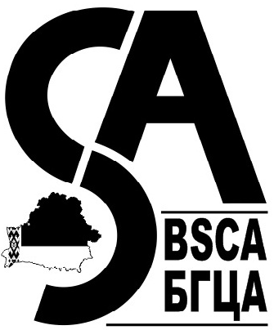

Figure 2.1 – Black-and-white version of BSCA logo

**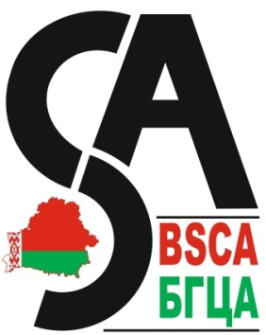**

Figure 2.2 – Colour version of BSCA logo

**Annex 3**

**Accreditation symbol**

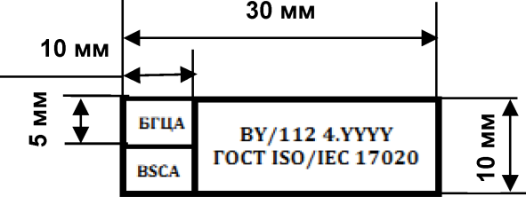

Figure 3.1 – Basic dimensions of the accreditation symbol

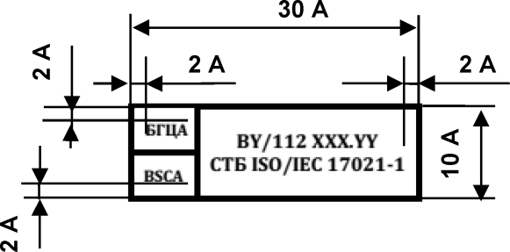

*where A is any natural positive number (A≥1)*

Figure 3.2 – The ratio of minimum indentations from overall

linear dimensions of the accreditation symbol

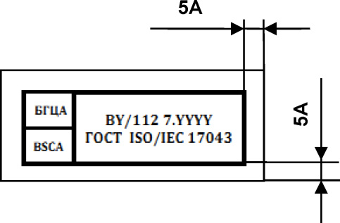

*where A is any natural positive number (A≥1)*

Figure 3.3 – The protective field of the accreditation symbol

# Annex 4

**ILAC MRA mark**

**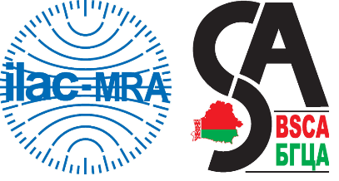**

Figure 4.1 – Colour version of

combined ILAC MRA mark

**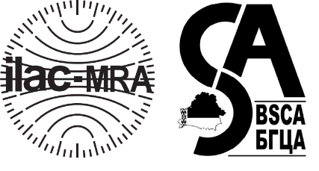**

Figure 4.2 – Black-and-white version of

combined ILAC MRA mark

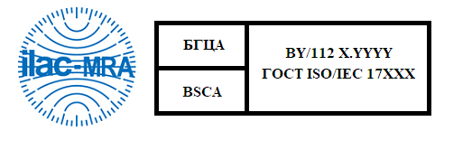

Figure 4.3 – Colour version of

combined ILAC MRA mark of the accredited CAB

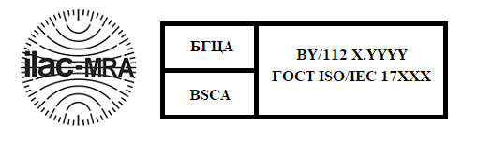

Figure 4.4 – Black-and-white version of

combined ILAC MRA mark of the accredited CAB

**Amendment registration sheet**

|  |  |  |  |  |  |
| --- | --- | --- | --- | --- | --- |
| Index number of the amendment | No. of the order on approval/order on activation | Date of approval/activation | Paragraph changed | Signature of the person who introduced the change | Name of the person who introduced the change |
| 1 | 2 | 3 | 4 | 5 | 6 |
|  |  |  |  |  |  |